Last Update: December 8, 2020

Enterprise Route Management

*Workforce Deployment and Integration Guide*

**Table of Contents**

**Section Title Page**

1.0 About This Document 2

1.1 Purpose 2

1.2 Authors & Contributors 2

1.3 Revision History 2

2.0 Workforce for ERM 3

2.1 Install Workforce 3

2.2 Create Workforce Project 3

2.3 Publish Sync Service 4

2.4 Configure ERM API for Workforce 4

2.4.1 User Credentials 5

2.4.2 Automatic Assignment Cleanup 5

2.5 Portal Users 6

2.6 Sanity Test 6

1. About This Document
   1. Purpose

This Application Deployment Guide serves to document steps for deployment of Workforce and integrating with the Enterprise Route Management (ERM) application.

There are precursor steps for setting up the underlying environment and deploying the ERM. These steps are included in separate documents *ERM Environment Setup Guide* and *ERM Application Deployment Guide.*

* 1. Authors & Contributors

|  |  |  |  |
| --- | --- | --- | --- |
| Author | Role/Title | Email | Phone |
| Mike Nelson | Esri Release Manager | mnelson@esri.com | (909) 793-2853 x5202 |
| Michael Gayheart | Esri Scrum Master | mgayheart@esri.com | (909) 793-2853 x4426 |
| Ashley DePottey | Esri Tech Lead | adepottey@esri.com | (909) 793-2853 x1824 |

* 1. Revision History

|  |  |  |
| --- | --- | --- |
| Date | Description | Editor |
| 8/18/2020 | Initial Draft v0.1 | Mike Nelson |
| 8/20/2020 | Applied Internal Feedback | Mike Nelson |
| 9/10/2020 | Updates on user accounts | Mike Nelson |
| 12/8/2020 | Adjust bracket note for user ID | Mike Nelson |

1. Workforce for ERM
   1. Install Workforce

Starting with the [10.8.1 version](https://enterprise.arcgis.com/en/portal/latest/administer/windows/what-s-new-in-portal-for-arcgis.htm) of ArcGIS Enterprise, Workforce is included and no longer has a separate installer. See [core documentation](https://doc.arcgis.com/en/workforce/android-phone/help/workforce-enterprise-support.htm) on installation with older version.

* + 1. Workforce while Offline

The initial version of 10.8.1 included Workforce Classic, which does not support Offline mode. If you have an install prior to September of 2020, you will need to apply a QFE (Quick Fix Engineering, i.e. Hotfix).

1. Esri Project team will have provided a .msp file. Copy to the ERM Enterprise machine where Portal is installed.
2. On the ERM Enterprise machine, browse to C:\Program Files\ArcGIS\Portal\apps
3. You should have a workforce and a workforce-old folder.
   1. The workforce-old might be named slightly different.
4. Rename the workforce folder to workforce-new.
5. Rename the workforce-old folder to workforce.
6. Run the .msp file.
   1. Note that this process can take over an hour to complete. It may periodically ask for administrator access and you will have to click yes. Not clicking yes in timely fashion may cause process to fail.
   2. Create Workforce Project

Once Workforce is installed, follow these steps to create a project for ERM to use.

1. Browse to https://<portal url>/portal/apps/workforce
   1. Use administrator account that will own the project items.
2. Click Create Project
3. Give a descriptive name, such as ERM Workforce
4. Add the following assignment types:
   1. Pickup
   2. Delivery
5. Add the Portal User accounts that correspond to driver accounts.
   1. There is a link on that page that shows how to batch load from a list if there are many accounts to add.
6. Once project is created, open Portal.
7. A folder will be created with the name of your project (i.e. ERM Workforce)
8. Open the folder and confirm there are 2 web maps and 1 feature layer

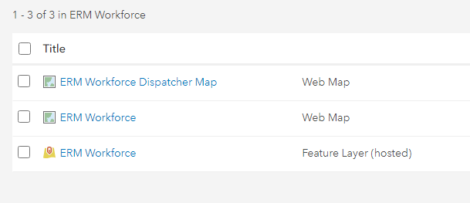

1. Share all 3 items, following same pattern used to share other ERM items
   1. Can share with entire organization.
   2. Can share with a generic ERM group that all users are a part of.
   3. Publish Sync Service

There is a windows service for syncing Workforce with the ERM.

1. Find the scripts folder where the ERM API was installed from. Verify there is a Workforce folder.
   1. This will vary depending on where it was deployed. It will be on the middleware machine under <install location>\ERM\scripts\Workforce
2. Open an administrator command prompt.
3. Change path in prompt to the scripts\Workforce directory.
4. Run the following command:
   1. *node install-workforce-windows-service.js*
5. Open the Windows services and make sure that there is a service called 'ERM-Workforce Sync’. If it's not started, start it. If the service does not exist, or you can't start it, check the log files located in the middleware\src\daemon directory.
   1. Configure ERM API for Workforce

The are several values to update in the ERM API (Middleware) configuration for integrating Workforce with ERM

config.workforce = {

layersItemId: "c848ff1562194e69a5d468b37a2839cb",

dispatcherId: "{76da0172-8b96-40bd-8fd6-79d0719a16ee}"

};

~~~~~~~~~~~

config.sync.logging = {

level: process.env.LOG_LEVEL || "info",

filename: process.env.SYNC_LOG_FILE || "C:\arcgis\ERM\logs\erm_sync.log",

maxsizeinbytes: process.env.LOG_SIZE_BYTES || 200000000,

maxfiles: process.env.LOG_MAX_FILE_COUNT || 15

};

1. Open the config file for the ERM API.
   1. This will vary depending on where it was deployed. It will be on the machine <install location>\Middleware\src\config\config.json
2. Update 2 values in config.workforce section.
   1. layersItemID = the ID of the Feature Layer created when the Workforce project was set up. Can be found by opening item in Portal and copying from URL.
   2. dispatcherID = the ID of the GlobalID of user that created the Workforce project. Can be found opening the Feature Layer from the Workforce project, opening the Dispatchers table, and copying the GlobalID value.
      1. DispatcherID value needs to have brackets around the ID
      2. Note: if you open table through ArcGIS Pro you will be able to copy the value. Opening through Portal will not enable copy/paste.
3. Update the log information for the sync service.
   1. Set the SYNC_LOG_FILE to where to write log information to. Include both path and file name.
      1. Recommended to put in same location as ERM Middleware log.
   2. Can optionally adjust log file size, number of files to retain, and level of logging.
      1. User Credentials

The credentials the sync service will use need to be stored in environment variables.

1. On the machine where the sync service was published, create 2 environment variables.
   1. ERM_USER
   2. ERM_PWD
2. Set the values to the same user credentials as was used to create the Workforce project.
3. Restart Workforce Sync service.
   * 1. Automatic Assignment Cleanup

In the Middleware configuration file, there are option to automatically delete older Assignment features in the Workforce feature service. This process uses the Workforce layer that was configured in previous section.

* config.delete = {};
  + This line needs to be present, no change needed. If you do not want automatic cleanup to run, comment out this line.
* config.delete.intervalHours = 1
  + This is how often the automatic delete process runs.
* config.delete.hoursToSave = 36;
  + Any Workforce feature with a last_edited_date that is older than the time the process runs – hours to save is deleted.
  + NOTE: last_edited_date is stored in UTC. The process will use whatever local time the Middleware server is in. May need to adjust hoursToSave to account for conversion.
  1. Portal Users

On a Route, the Assigned To field can be used to assign a route to a Portal user. Note that these user accounts need to be set to public for the application to see them. That setting can be found on the user profile page.

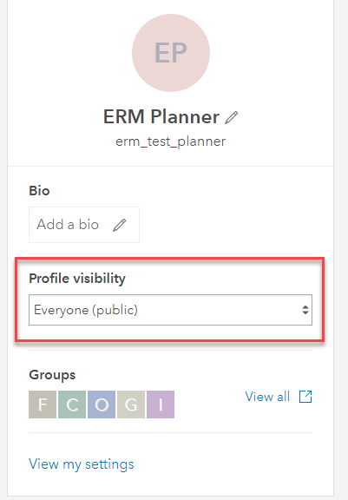 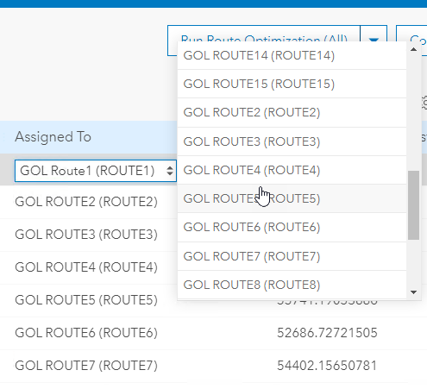

* 1. Sanity Test

Run these steps to validate that Workforce was installed and configured correctly.

1. Open the ERM application.
2. Create a new Plan.
3. Solve at least one Route.
4. Commit at least one Route.
5. Open the Workforce Feature Layer in Pro or in a web map.
6. Open the Assignments table
7. Verify the number of assignments match up with the number of orders on the committed routes.
8. Change the notes of an assignment and see that the change is reflected in the corresponding GeoOrder in ERM plan.